

**DGR**

**as a hypothetical bacterial immune system**

Sokolov Arseny

FS11-63B

# Bioinformatics

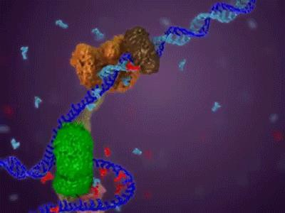

**Bioinformatics**

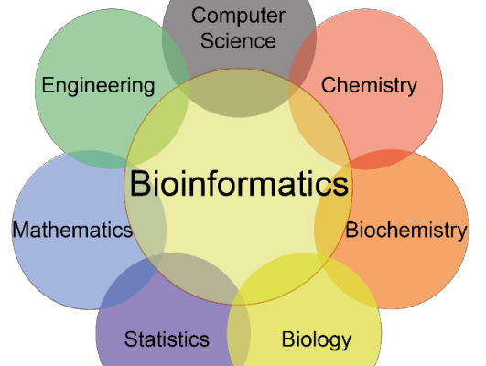

### What is DNA?

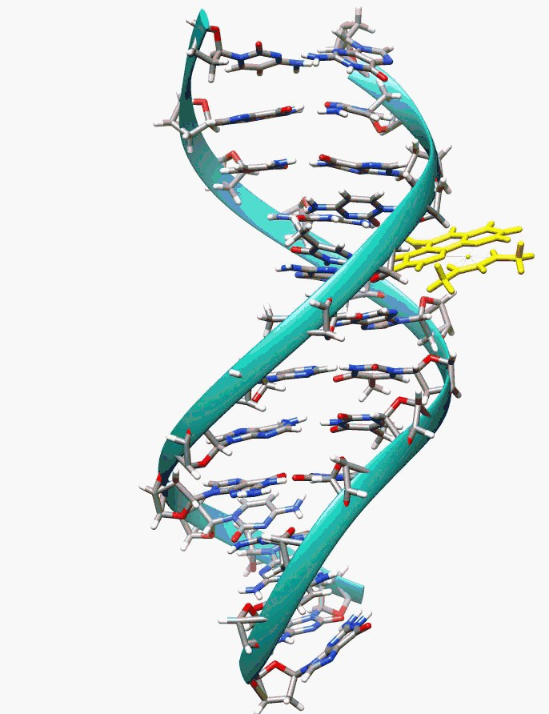

What is DNA?

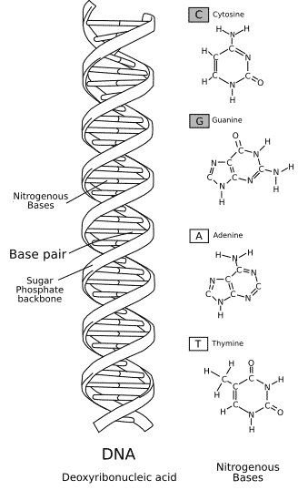

What is DNA?

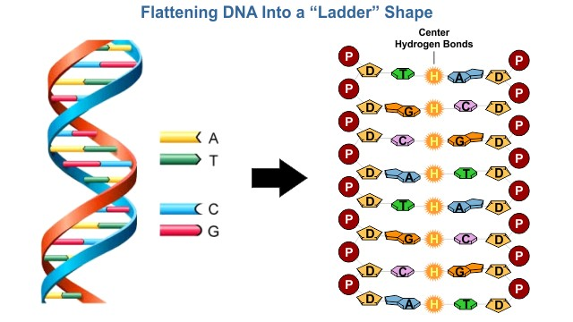

What is DNA?

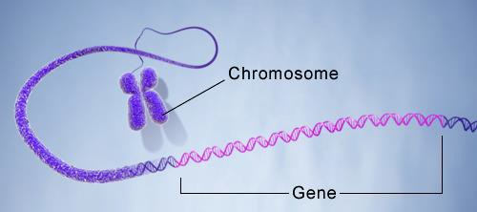

What is DNA?

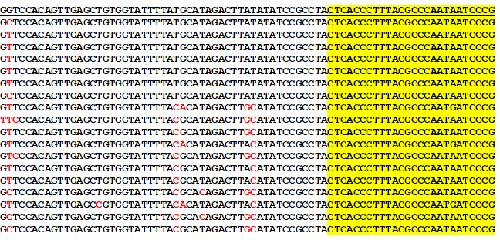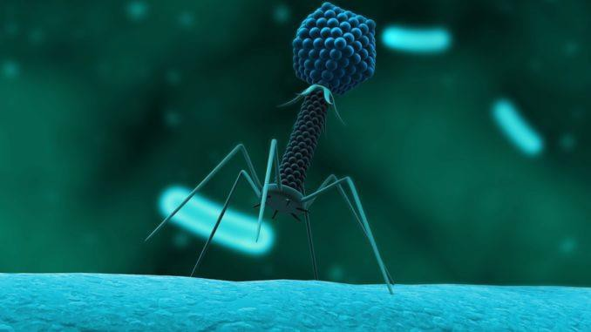



INTRODUCTION

* Operons — arrays of co-expressed and

coregulated genes

➢ Operons — arrays of co-expressed and

coregulated genes

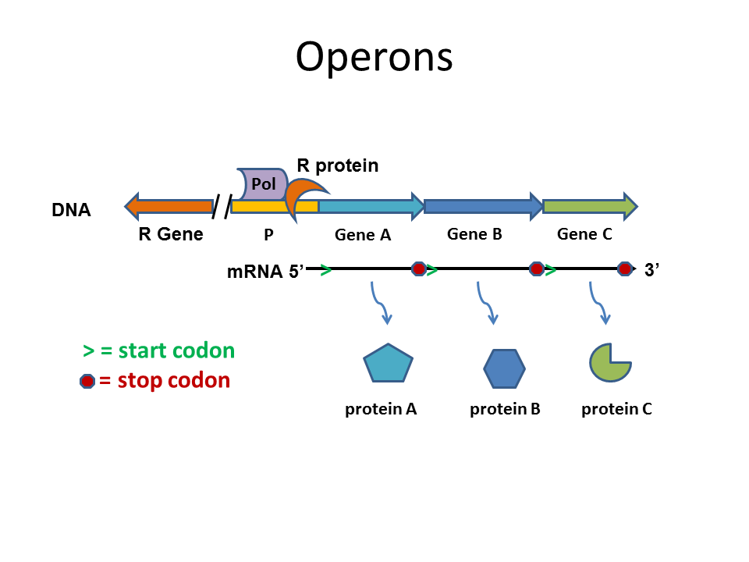

INTRODUCTION



INTRODUCTION

* Operons — arrays of co-expressed and

coregulated genes

* ICITY — protocol to systematic prediction of functionally linked genes in bacterial and archaeal genomes

➢ Operons — arrays of co-expressed and

coregulated genes

➢ ICITY — protocol to systematic prediction of functionally linked genes in bacterial and archaeal genomes

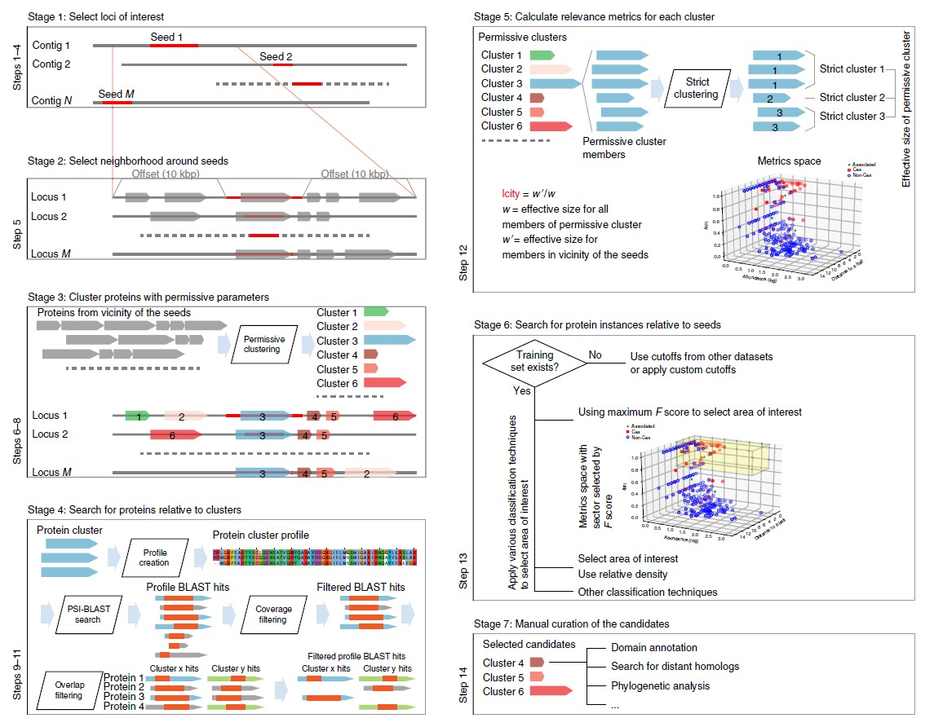

INTRODUCTION



INTRODUCTION

* Operons — arrays of co-expressed and

coregulated genes

* ICITY — protocol to systematic prediction of functionally linked genes in bacterial and archaeal genomes
* DGR —recently discovered operons

➢ Operons — arrays of co-expressed and

coregulated genes

➢ ICITY — protocol to systematic prediction of functionally linked genes in bacterial and archaeal genomes

➢ DGR —recently discovered operons

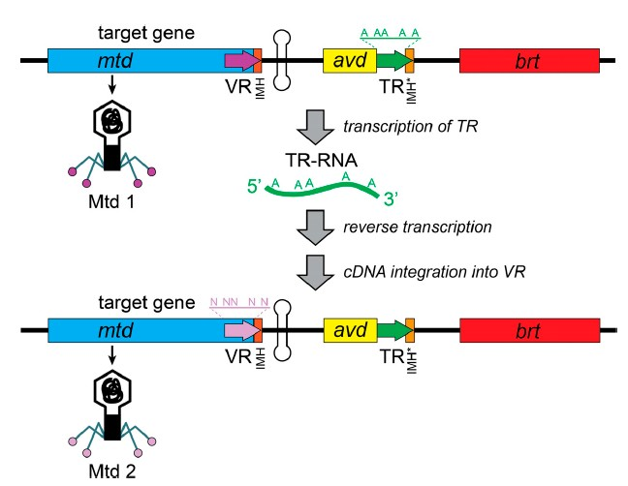

INTRODUCTION

Our results

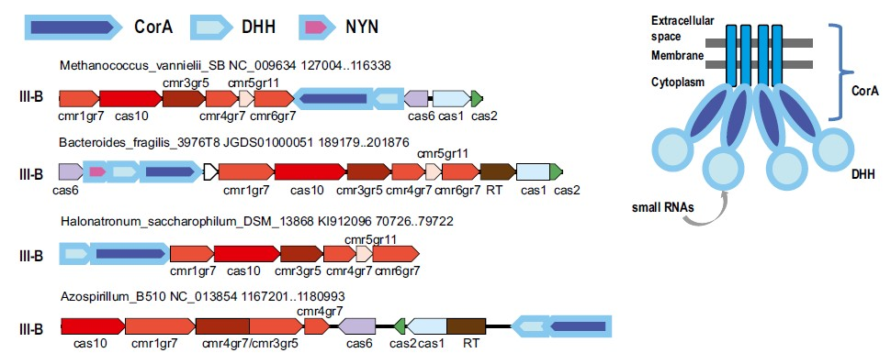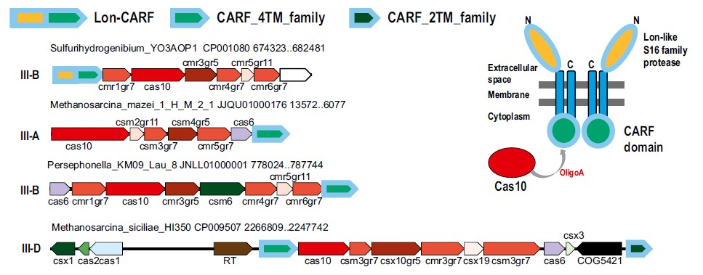

Our results

